PHYS 216 Assignment 2

Nicholas Pun (27872167)

Question 3

a)

The desired values are T = 78.246 s and v_imp = 766.81 m/s. The largest timestep I was able to find was dt = 0.3 s. This gave me a result of T = 78.300 s and v_imp = -767.34 m/s. T is within 0.1s of the real value, and v_imp is within 1% of the real value. Timesteps larger than 0.3 s becomes a game of chance of how close one can land near the real value as they no longer consistently result at the desired accuracy. For example, a timestep of 1.15 s results in T = 78.2 s, but a timestep of 1.0 s, a smaller timestep, results in T = 78.0 s, which is less accurate value.

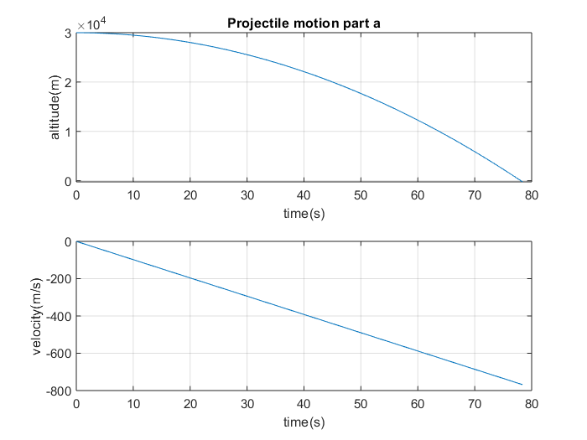

b)

I used a timestep of dt = 0.0001 s to achieve a result of good accuracy, which I then based the accuracy of my tested values on. The desired values are then T = 324.156 s and v_imp = -44.554152 m/s. The largest timestep I was able to find was 1.8 s, which gave values of T = 315.000 s and v_imp = -44.471186 m/s. These are to the desired accuracy. However, I was able to find larger timesteps which gave an accuracy within the desired range, but these timesteps are not being considered as they are timesteps were the final value is a game of chance like before. For example, I found that at a timestep of 5 s, I got T = 315.000 s, whereas a timestep of 4 s resulted in T = 316.000 s. Another example is, a timestep of 9.488888 s results in T = 313.133304 s whereas a timestep of 9 s results in T = 333.000 s. Both these examples show that higher timesteps are no longer consistently accurate and that their resulting accuracies are just a form of luck.

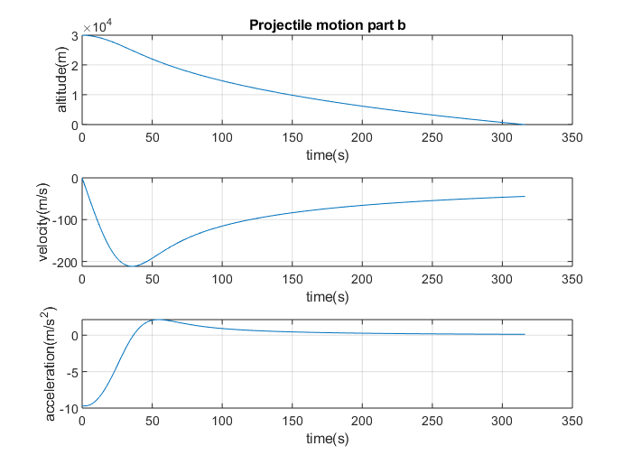

To get within an accuracy of 0.1 s, for the same reasons as above, required that the timestep be no larger than 0.2 s, which resulted in T = 314.200 s and v_imp = -44.551040 m/s. The cost of that computation was 1572 steps. I found that a timestep of 0.979 s resulted in T = 314.238 s, which is within 0.1 s, but again this was just luck as a timestep of 0.9 results in T = 315.000 s, which is less accurate.